**Chapter 3 learning**

* **Learning** is any relatively durable change in behavior or knowledge that is due to experience or a relatively permanent change in behavior brought about by experience.
* **Types of learning**

**1) Trial & Error Learning (Thorndike) –** maze learning to get food eg. With rats

**2) Insight Learning (Wolfgang Kohler)**

A cognitive form of learning involving the mental rearrangement or restructuring of the elements in a problem to achieve a sudden understanding of the problem and arrive at a solution. Eg giving 2 small sticks to apes to reach food that is places very high. Combined sticks can reach

**3) Learning by Imitation or observational learning (Albert Bandura)**

 The acquisition of information, skills, or behavior through watching the performance of others, either directly or via such media as films and videos. Also called vicarious learning.

Observational learning is the process of learning by watching the behaviors of others. The targeted behavior is watched, memorized, and then mimicked. Also known as shaping and modeling, observational learning is most common in children as they imitate behaviors of adults.

**4) Cognitive Learning (E.C. Tolman)**

Cognitive learning theory focuses on how people acquire, process, and retain knowledge. It suggests that learning involves more than just responses to stimuli; it emphasizes understanding the internal processes that take place in the mind, such as memory, attention, and problem-solving.

Imagine you're trying to navigate through a large university campus. The first time you visit, you only know the route from the main gate to the library. A few days later, you learn a new route from the library to the cafeteria. As you keep visiting the campus, you explore other places, like the gym or the student center.

According to **Cognitive Map** Theory, your brain combines all these individual routes into a mental map of the campus. This map helps you figure out how to go from one place to another, even if you’ve never traveled that specific route before. For instance, if you need to go from the gym to the cafeteria, you can mentally recall pieces of different routes and integrate them to find your way.

**Cognitive abilities** include code (understand new thing), store, recall and decode (make sense of memory).

**5) Conditioning (Classical Conditioning (Ivan Pavlov) Operant Conditioning (B.F. Skinner)**

* Conditioning is learning by associating things / events that occur in organism’s environment. **Conditioning:** The process of evoking a specific response other than natural response by presenting a particular stimulus.

**Classical conditioning: (Ivan Pavlov)** suggests that learning occurs when an association is formed between a previously neutral stimulus and a naturally occurring stimulus.

* **Unconditioned Stimulus:** is a stimulus that naturally brings about a particular response without having been learned.
* **Unconditioned Response:** is a natural, innate response that occurs automatically and needs no training.
* **Conditioned Stimulus:** is a once-neutral stimulus that has been paired with an unconditioned stimulus to bring about a response formerly caused only by the unconditioned stimulus.
* **Conditioned Response:** A learned response (salivating when bell rang even when food wasn’t there)
* **Neutral stimulus:** is a stimulus that, before conditioning, does not naturally bring about the response in which we are interested. Eg. Ringing of bell before experiment

**Basic Principles of CC**

* **Acquisition:** It refers to the initial stage of learning a new response tendency
* **Extinction:** When a conditioned stimulus eventually losses its ability to bring about a conditioned response. Experimenter kept ringing bell and eventually the dog no longer salivated to the bell only.
* **Spontaneous Recovery:** When a conditioned response occurs after extinction. Extinction had occurred, a day or two had passed during which the dogs did not hear the bell at all. After this rest period, the bell was rung and caused salivation (not as much saliva produced, but some)
* **Generalization:** Act of responding in the same ways to stimuli that seem to be similar, even if the stimuli are not identical. My dad used to call us home with a whistle. One day another dad whistled, however, I thought it was mine and went home.
* **Discrimination:** Responding differently to stimuli that are not similar to each other. Example: Response to fire bell is different to your response to the bell that changes classes.

**Examples of cc**

* The earlier illustration of how people may experience hunger pangs at the sight of McDonald’s golden arches. The cause of this reaction is classical conditioning: The previously neutral arches have become associated with the food inside the restaurant (the unconditioned stimulus), causing the arches to become a conditioned stimulus that brings about the conditioned response of hunger.
* For example, you may not go to a dentist as often as you should because of previous associations of dentists with pain. In more extreme cases, classical conditioning can lead to the development of phobias, which are intense, irrational fears. For example, an insect phobia might develop in someone who is stung by a bee. The insect phobia might be so severe that the person refrains from leaving home.
* Posttraumatic stress disorder (PTSD), suffered by some war veterans and others who have had traumatic experiences, can also be produced by classical conditioning.
* you may have a particular fondness for the smell of a certain perfume or aftershave lotion because thoughts of an early love come rushing back whenever you encounter it. Or hearing a certain song can bring back happy or bittersweet emotions due to associations that you have developed in the past. Classical conditioning also explains why drug addictions are so difficult to treat. Drug addicts learn to associate certain stimuli—such as drug paraphernalia such as a syringe or a room where they use drugs—with the pleasant feelings produced by the drugs. So simply seeing a syringe or entering a certain room can produce reactions associated with the drug and continued cravings for it.

**Operant conditioning: (B.F skinner)** is a type of associative learning that involves strengthening or weakening a behavior by using reinforcement or punishment. Punishment types

**Reinforcement** is the process by which a stimulus increases the probability that a preceding behavior will be repeated.

**Types of reinforcers**

* **A primary reinforcer** satisfies some biological need and works naturally, regardless of a person’s previous experience. Food for a hungry person, warmth for a cold person, and relief for a person in pain all would be classified as primary reinforcers.
* **A secondary reinforcer** is a stimulus that becomes reinforcing because of its association with a primary reinforcer. For instance, we know that money is valuable because we have learned that it allows us to obtain other desirable objects, including primary reinforcers such as food and shelter.

**Schedules of reinforcement :**

Continuous: Reinforcement of a behavior every time the behavior occurs…since this is not practical…a lot of times the behavior is short lived and will disappear very quickly if the reinforcement stops for any period of time (example: rewarding kindergarten student a star(s) on hand/face, emoticon of smiley in marking)

Partial or Intermittent: Behavior is not reinforced every time the behavior occurs, instead, it is given intermittently…the behavior learned through this type of reinforcement tends to last longer after the reinforcement ends (example: marks in mid-1, mid-2, & final exams)

**Basic Principles of OC**

* **Acquisition:** is the formation of a new response tendency.
* **Shaping :** A technique used to teach complex behaviors by reinforcing small steps in the right direction.
* **Extinction:** refers to the gradual weakening and disappearance of a response tendency because the response is no longer followed by reinforcement.
* **Generalization:** Response increases in the presence of new stimulus that resembles the original (discriminative) stimulus
* **Discrimination:** Response does Not increase in the presence of new stimulus that resembles the original (discriminative) stimulus.

1. **Types of Partial Reinforcement**:

* **Fixed-Ratio Schedule**: You get a reward after doing something a set number of times (like getting paid for every 10 shirts you sew).
* **Variable-Ratio Schedule**: You get a reward after a random number of tries, but it averages out over time (like a salesperson who makes a sale after random numbers of calls). This leads to more consistent effort and is harder to extinguish.

1. **Interval Schedules** (Based on Time, Not Number of Actions):

* **Fixed-Interval Schedule**: You get a reward after a specific amount of time has passed, regardless of how much you do (like getting a paycheck every week). People often slow down after getting the reward and only start working hard again when the next reward is near (e.g., students cramming right before an exam).
* **Variable-Interval Schedule**: You get rewards after unpredictable periods of time (like surprise quizzes). This keeps people working more steadily because they don’t know when the next reward will come.

-The process by which people learn to discriminate stimuli is known as stimulus control training.

**Factors influencing behavior**

Motivation, Interest, Reward and punishment, Group participation, Familiarity, Meaningfulness

**Chapter 4: Memory**

* The initial process of recording information in a form usable to memory, a process called ***encoding***, is the first stage in remembering something.
* Memory specialists speak of ***storage***, the maintenance of material saved in memory. If the material is not stored adequately, it cannot be recalled later.
* ***retrieval***: Material in memory storage has to be located and brought into awareness to be useful.
* psychologists consider **memory** to be the process by which we encode, store, and retrieve information. Each of the three parts of this definition—encoding, storage, and retrieval— represents a different process.

**Three-system approach to memory**

* Sensory memory refers to the initial, momentary storage of information that lasts only an instant. Here, an exact replica of the stimulus recorded by a person’s sensory system is stored very briefly. in sensory memory consists of representations of raw sensory stimuli, it is not meaningful to us.
* In a second stage, short-term memory holds information for 15 to 25 seconds and stores it according to its meaning, rather than as mere sensory stimulation. If sensory doesn’t give information to short term then it is lost.
* The third type of storage system is long-term memory. Information is stored in long-term memory on a relatively permanent basis, although it may be difficult to retrieve.

**Types of sensory memories**

1. Iconic memoryreflects information from the visual system.
2. Echoic memorystores auditory information coming from ears

**Short-Term Memory**

* Short-term memory is the memory store in which information first has meaning
* **A chunk** is a group of separate pieces of information stored as a single unit in short-term memory. For example, telephone numbers are typically depicted in three chunks of information in order to make them easier to remember: (201) 226-4610, rather than a string of the separate numbers 2012264610.
* The transfer of material from short- to long-term memory proceeds largely on the basis of **rehearsal,** the repetition of information that has entered short-term memory.
* if the information in short-term memory is rehearsed using a process called elaborative rehearsal, it is much more likely to be transferred into long-term memory. **Elaborative rehearsal** occurs when the information is considered and organized in some fashion. The organization might include expanding the information to make it fit into a logical framework, linking it to another memory, turning it into an image, or transforming it in some other way.

**Working Memory**

* Working memory is the memory system that holds information temporarily while actively manipulating and rehearsing that information.
* working memory is made up of several parts. First, it contains a **central executive** processor that is involved in reasoning, decision making, and planning. The central executive integrates and coordinates information from three distinct subsystems, and it determines what we pay attention to and what we ignore. The three subsystems of working memory serve as storage-and-rehearsal systems: **the visual store, the verbal store, and the episodic buffer.** The visual store specializes in visual and spatial information. In contrast, the verbal store holds and manipulates material relating to language, including speech, words, and numbers. Finally, the episodic buffer contains information that represents events and occurrences—things that happen to us

**Long-Term Memory**

* **Declarative memory** is memory for factual information: names, faces, dates, and facts, such as “a bike has two wheels.” The information stored in declarative memory can be verbally communicated to others and is sometimes called “explicit memory.”
* Declarative memory can be subdivided into semantic memory and episodic memory. **Semantic memory** is memory for general knowledge and facts about the world, as well as memory for the rules of logic that are used to deduce other facts. In contrast, **episodic memory** is memory for events that occur in a particular time, place, or context. For example, recall of learning to hit a baseball, our first kiss, or arranging a surprise 21st birthday party for our brother is based on episodic memories.
* In contrast, **procedural memory** (sometimes called nondeclarative memory or implicit memory) refers to memory for skills and habits, such as how to ride a bike or hit a baseball. For example, procedural memory allows us to ice skate, even if we haven’t done it for a long time.

**Semantic Memory**

According to some memory researchers, one key organizational tool that allows us to recall detailed information from long-term memory is the associations that we build between different pieces of information. In this view, knowledge is stored in semantic networks, mental representations of clusters of interconnected information.

**Recalling**

Have you ever tried to remember someone’s name, convinced that you knew it but unable to recall it no matter how hard you tried? This common occurrence—known as the **tip-of-the-tongue phenomenon**

* **Explicit memory** refers to intentional or conscious recollection of information. When we try to remember a name or date we have encountered or learned about previously, we are searching our explicit memory.
* In contrast**, implicit memory** refers to memories of which people are not consciously aware but that can affect subsequent performance and behavior. Skills that operate automatically and without thinking, such as jumping out of the path of an automobile coming toward us as we walk down the side of a road, are stored in implicit memory. Similarly, a feeling of vague dislike for an acquaintance, without knowing why we have that feeling, may be a reflection of implicit memories.
* **Flashbulb memories** are memories related to a specific, important, or surprising event that are so vivid they represent a virtual snapshot of the event. Several types of flashbulb memories are common among college students. For example, involvement in a car accident, meeting one’s roommate for the first time, and the night of high school graduation are all typical flashbulb memories
* **Autobiographical memory** is our recollections of our own life experiences.

**Why we forget?**

* **Decay**: This theory suggests that we lose memories over time due to disuse. The idea is that memory traces—physical changes in the brain when we learn something—fade away or break down if not used. However, this doesn’t fully explain forgetting, as people can sometimes recall information better after some time has passed, which contradicts the idea that all memories should weaken with time.
* **Interference**: This concept suggests that forgetting happens because other information in our memory interferes with what we're trying to remember. For example, recalling one person’s name might be harder if we keep thinking of someone else's name instead.
* **cue-dependent forgetting**, which happens when we can’t remember something because we lack the right clues or reminders to retrieve the memory. For example, if you lose your keys, you might not remember where they are until you mentally retrace your steps through your day. Thinking of a specific place, like the library, might trigger your memory and help you recall that you left the keys on a desk there. Without such cues, it can be difficult to remember certain information.

**Interference types**

1. In **proactive interference**, information learned earlier disrupts the recall of newer material. Suppose, as a student of foreign languages, you first learned French in the 10th grade, and then in the 11th grade you took Spanish. When in the 12th grade you take a college subject achievement test in Spanish, you may find you have difficulty recalling the Spanish translation of a word because all you can think of is its French equivalent.
2. In contrast, retroactive interference occurs when material that was learned later disrupts the retrieval of information that was learned earlier. If, for example, you have difficulty on a French subject achievement test because of your more recent exposure to Spanish, retroactive interference is the culprit

**Amnesia and its types**

* **In retrograde amnesia**, memory is lost for occurrences prior to a certain event but not for new events. Usually, lost memories gradually reappear, although full restoration may take as long as several years. In certain cases, some memories are lost forever. But even in cases of severe memory loss, the loss is generally selective. For example, although people suffering from retrograde amnesia may be unable to recall friends and family members, they still may be able to play complicated card games or knit a sweater quite well.
* A second type of amnesia is exemplified by people who remember nothing of their current activities. In **anterograde amnesia**, loss of memory occurs for events that follow an injury. Information cannot be transferred from short-term to long-term memory, resulting in the inability to remember anything other than what was in long-term storage before the injury

**Chapter 5: Personality**

**Personality** is the pattern of enduring characteristics that produce consistency and individuality in a given person.

**five-factor model of personality**

* 1. **Extraversion**. People who score high in extraversion are characterized as outgoing, sociable, upbeat, friendly, assertive, and gregarious.
  2. **Neuroticism.** People who score high in neuroticism tend to be anxious, hostile, self-conscious, insecure, and vulnerable.
  3. **Openness to experience.** Openness is associated with curiosity, flexibility, vivid fantasy, imaginativeness, artistic sensitivity, and unconventional attitudes.
  4. **Agreeableness.** Those who score high in agreeableness tend to be sympathetic, trusting, cooperative, modest, and straightforward. People who score at the opposite end of this personality dimension are characterized as suspicious, antagonistic, and aggressive.
  5. 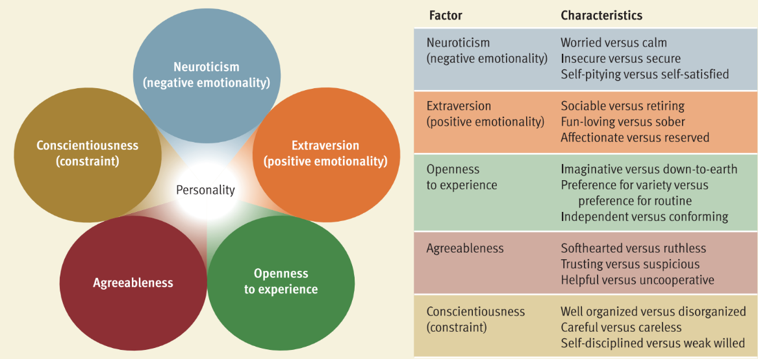**Conscientiousness.** Conscientious people tend to be disciplined, well organized, punctual, and dependable.

**Freuds iceberg theory (do conscious, un and preconscious)**

The **id** is the primitive, instinctive component of personality that operates according to the pleasure principle. which demands immediate gratification of its urges.

The **ego** is the decision-making component of personality that operates according to the reality principle. The ego is guided by the reality principle, which seeks to delay gratification of the id’s urges until appropriate outlets and situations can be found.

**Superego** is the moral component of personality that incorporates social standards about what represents right and wrong.

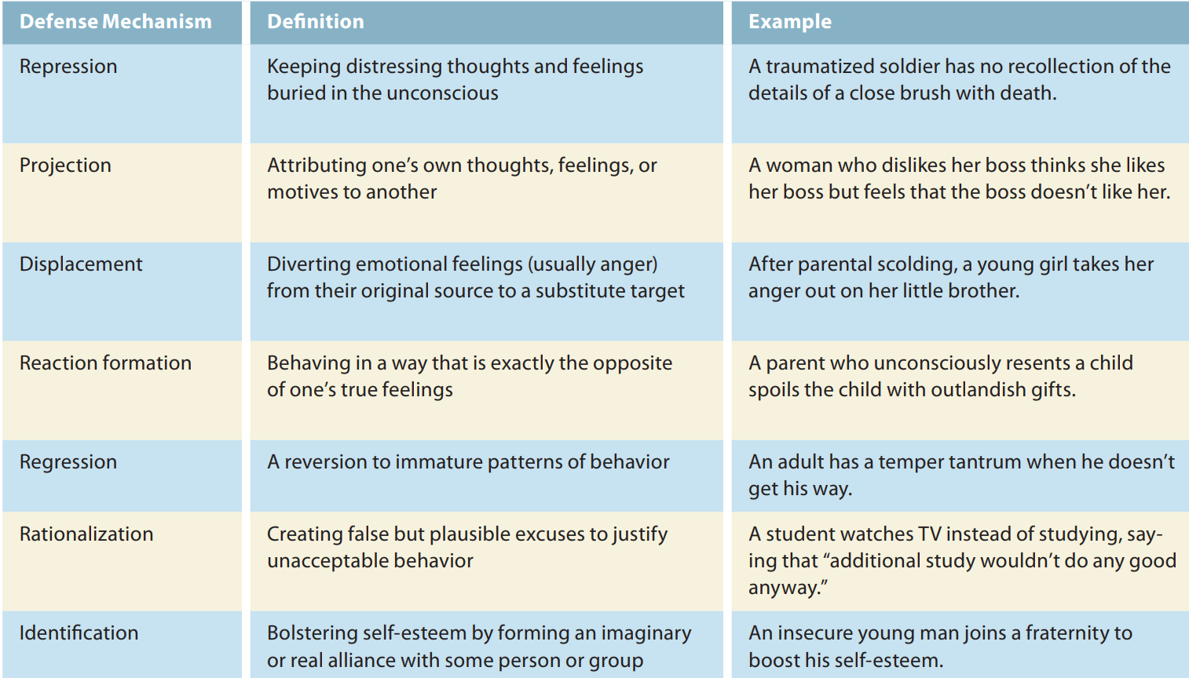

**Projection example: Dissatisfaction in Friendships**: If someone secretly feels resentful or envious of a friend’s success, they might start to believe that the friend is actually envious of them. This deflects attention from their own insecurities and reframes the problem as originating with the friend.

**Regression example:** When anxious about their self-worth, some adults respond with childish boasting and bragging (as opposed to subtle efforts to impress others). For example, a fi red executive having difficulty finding a new job might start making ridiculous statements about his incomparable talents and achievements

Freud's theory of **psychosexual stages** suggests that as children grow, they pass through a series of developmental stages where different parts of the body are the main focus of pleasure. How they manage challenges at each stage can leave lasting effects on their personality. If a child gets “stuck” at any stage, it can impact their behavior as an adult. This “stuckness” is called fixation and can happen if a child’s needs are either overindulged or neglected during a stage.

**1. Oral Stage (Birth to 1 Year)**

In the first year of life, a baby finds pleasure through activities involving the mouth, such as sucking, biting, and chewing. Feeding experiences, like weaning from breastfeeding or bottle-feeding, are very important at this stage. If a baby’s needs are not met well, they could become “fixated,” or stuck in this stage, and may develop habits like excessive eating, drinking, or smoking later in life.

**2. Anal Stage (1 to 3 Years)**

In this stage, the child’s pleasure centers on their bowel movements. Potty training becomes a key challenge, as it’s one of the first times they face rules about their body. How parents approach potty training can impact the child’s personality. For example, if parents are overly strict, the child might become very organized and perfectionistic (often called “anal-retentive”) or, on the other hand, messy and rebellious (known as “anal-expulsive”).

**3. Phallic Stage (3 to 6 Years)**

During this stage, children start to focus on their genitals and may develop feelings for the opposite-sex parent, known as the Oedipus complex. For boys, this means a strong attachment to their mother and jealousy toward their father; for girls, it’s the reverse. Children eventually need to let go of these feelings to bond with the same-sex parent. This identification with the same-sex parent helps children develop gender roles and conscience. Problems with this stage can lead to difficulties in forming relationships or authority issues later in life.

**4. Latency Stage (6 to Puberty)**

In the latency stage, children’s sexual interests become less intense. Instead, they focus on making friends, learning new skills, and building social relationships outside of their family. This stage is mostly about personal and social growth, with fewer challenges directly tied to sexual development.

**5. Genital Stage (Puberty to Adulthood)**

As teenagers reach puberty, they enter the genital stage, where sexual interests reawaken, but now the focus is on relationships with others rather than self-centered pleasure. Healthy development at this stage means they direct their sexual energy toward forming romantic relationships with others. If the earlier stages were resolved well, they are more likely to have healthy relationships and a well-rounded personality.

**JUNG’S ANALYTICAL PSYCHOLOGY**

Unlike Freud, who preferred a structured approach, Jung encouraged his followers to think independently

Both Jung and Freud believed that unconscious thoughts and feelings shape our personalities, but Jung’s ideas about the unconscious were different. He proposed that the unconscious mind has two parts:

1. **Personal Unconscious**: This is similar to Freud’s idea of the unconscious, containing memories and feelings that a person is unaware of because they have been repressed (pushed out of awareness) or forgotten.
2. **Collective Unconscious**: This is a deeper, shared level of the unconscious mind that Jung believed all humans inherit from their ancestors. The collective unconscious includes universal memories and experiences passed down through generations, connecting everyone across time and culture.

Within the collective unconscious, Jung said there are **archetypes**—universal, emotionally charged images and ideas that show up in dreams, art, literature, and religion. These archetypes are not memories of specific personal experiences but are symbols or ideas with deep, shared meanings for all humans. For example, one archetype is the **mandala**, or “magic circle,” which symbolizes unity and wholeness of the self. Jung found that many cultures use similar symbols, such as the mandala, even if they have never interacted, suggesting that these symbols come from the shared collective unconscious. Jung believed that understanding these symbols and archetypes helped him interpret his patients’ dreams, which he considered to be messages from the unconscious. Like Freud, he used dream analysis to understand his patients and uncover insights about their hidden thoughts and feelings.

**ALFRED ADLER INDIVIDUAL PSYCHOLOGY**

Unlike Freud, who focused on unconscious conflicts about sexuality, Adler believed the main human motivation was a desire to **strive for superiority**—to grow, improve, and overcome life’s challenges. Adler argued that early feelings of inferiority (especially as young children compare themselves to adults) motivate people to build new skills and abilities. He called this process **compensation**, which is a normal way of overcoming perceived or real weaknesses. However, when feelings of inferiority become too intense, they can lead to an **inferiority complex**—a constant feeling of weakness or inadequacy.

When a person has an inferiority complex, they might engage in **overcompensation**—focusing on status, power, or possessions (like flashy clothes or cars) to hide their feelings of inferiority from themselves and others. This self-deception makes people focus more on appearances than genuine self-improvement. WOAH NICE

Adler also believed that personality is shaped by social factors, like **birth order**. He proposed that the order in which a child is born influences personality, as each child experiences different dynamics in the family. For example, he suggested that only children might be spoiled, and first-borns might struggle when a new sibling arrives, leading them to become “problem children.” Although later research largely found little support for Adler’s birth order theory, the idea inspired further studies.

In recent years, Frank Sulloway has revisited birth order’s potential role in personality. Sulloway argued that birth order might shape traits like the **Big Five** personality traits, particularly through sibling competition for family roles. He suggested that first-borns might be more conscientious but less open and agreeable, tending to be more conventional and achievement-oriented, while later-borns might be more liberal and rebellious.

**B.F. Skinner's Behavioral Approach to Personality**

when responses are followed by favorable consequences (reinforcement), they are strengthened. For example, if your joking at a party pays off with favorable attention, your tendency to joke at parties will increase. Skinner believed that conditioning in humans operates much the same as it did in the rats and pigeons that he studied in his laboratory. Hence, he assumed that conditioning strengthens and weakens response tendencies “mechanically”—that is, without the person’s conscious participation.

**ALBERT BANDURA’S SOCIAL COGNITIVE THEORY**

Albert Bandura was one of the key theorists who modified traditional behaviorism by adding a cognitive element to it, especially in the 1960s. Unlike B.F. Skinner, who focused mainly on behavior shaped by the environment, **Bandura,** along with others like **Walter Mischel** and **Julian Rotter,** argued that human beings are not just reactive creatures molded by external forces. Instead, they are conscious, thoughtful, and emotional beings. These theorists initially called their approach **social learning theory**, but Bandura later renamed it social cognitive theory.

He emphasized that humans are self-organizing, proactive, and self-regulating, meaning they are active participants in shaping their behavior rather than passive recipients of external influences. According to Bandura, people set their own goals, plan for the future, and choose actions based on their predictions of outcomes. They seek to achieve desired results and avoid negative ones. Bandura’s theory is based on the concept of **reciprocal determinism**. This idea suggests that a person’s behavior, their personal beliefs and expectations (cognitive factors), and the environment all interact and influence each other. While the environment can influence behavior, people can also actively shape their environment. For example, a person can choose who they spend time with, which can alter their surroundings and, in turn, their behavior. They participate in shaping their surroundings, and this interaction can even give insights into their personalities based on how they influence and adapt to their physical environments.

Bandura's idea that people shape their environments suggests that rooms and houses can reflect the personalities of the people who live there. For instance, a **room** filled with unconventional decor, like abstract art or unique furniture, may signal that the occupant is creative or open to new experiences. Conversely, a space with formal decor and traditional furniture might reflect a more conventional, organized personality. (rooms has personality)

⭐ MEMORIZE NAMES = B. F. Skinner, Albert Bandura, and Walter Mischel. ⭐

**SELF EFFICACY:**

Self-efficacy refers to one’s belief about one’s ability to perform behaviors that should lead to expected outcomes.

**High Self-Efficacy**: If you believe you're good at talking to people, you might feel confident to join a new club or make new friends easily. This confidence can encourage you to take action.

**Less Procrastination**: People with high self-efficacy are more likely to complete tasks on time. **Better Health Outcomes**: Individuals who believe they can quit smoking are more successful in doing so. **Higher Academic Success**: Students with strong self-efficacy tend to achieve better grades. **Improved Mental Health**: High self-efficacy is associated with lower anxiety and depression levels.

**HUMANISTIC PERSPECTIVE**

**Backlash Against Other Theories**: Humanistic psychology arose as a reaction to:

* **Freudian Theory**: Criticized for focusing on primitive drives and unconscious conflicts.
* **Behaviorism**: Criticized for its mechanistic view and reliance on animal research, suggesting a fragmented understanding of human behavior.

They assume that (1) people can rise above their primitive animal heritage and control their biological urges, and (2) people are largely conscious and rational beings who are not dominated by unconscious, irrational needs and conflicts. (important memorize these two points)

**person-centered theory**

self-concept comprises beliefs about one's nature, unique qualities, and typical behavior, effectively serving as a mental image of oneself. For instance, an individual’s self-concept may include beliefs like “I’m easygoing,” “I’m crafty,” or “I’m hardworking.” Rogers posited that people are generally aware of their self-concept, which is not hidden in the unconscious. However, he acknowledged its subjective nature, noting that individuals often distort their experiences to maintain a favorable self-concept. For example, someone may believe they are intelligent despite receiving poor grades, leading to a state Rogers termed **incongruence**, the disparity between one’s self-concept and actual experiences. In contrast, a self-concept that accurately reflects reality is considered **congruent.**

In terms of personality development, Rogers believed childhood experiences play a crucial role in shaping congruence or incongruence. He argued that individuals have a fundamental need for affection, love, and acceptance from others, particularly from parents during early life. Some parents provide conditional love, meaning their affection depends on the child’s behavior and adherence to expectations. When children perceive parental love as conditional, they may block out experiences that make them feel unworthy of love, leading to a distorted self-concept. Conversely, unconditional love fosters a sense of worthiness, allowing children to accept their experiences more fully without distorting them. Rogers theorized that individuals who grow up with a conditional view of affection tend to distort their experiences to seek acceptance from others. He also highlighted that experiences threatening one’s self-perception are primary sources of anxiety. Individuals with highly incongruent self-concepts are more susceptible to anxiety because their perceptions often clash with reality. To cope with this anxiety, people might engage in defensive behaviors, such as ignoring or denying experiences that threaten their self-concept. For example, a woman who views herself as “nice” but exhibits selfish behavior might disregard moments of selfishness or rationalize negative feedback from others as jealousy or disappointment.

**Maslow's Theory of Self-Actualization and hierarchy of needs**

He famously stated that while Freud focused on the "sick half" of psychology, it was essential to explore the "healthy half.". Maslow proposed that human motivations are organized into a **hierarchy of needs**, often illustrated as a pyramid. The pyramid consists of levels, with basic needs at the bottom, such as physiological and security needs. These must be satisfied before higher-level needs can be addressed. The highest need is **self-actualization**, which is the drive to realize one’s potential and become the best version of oneself.

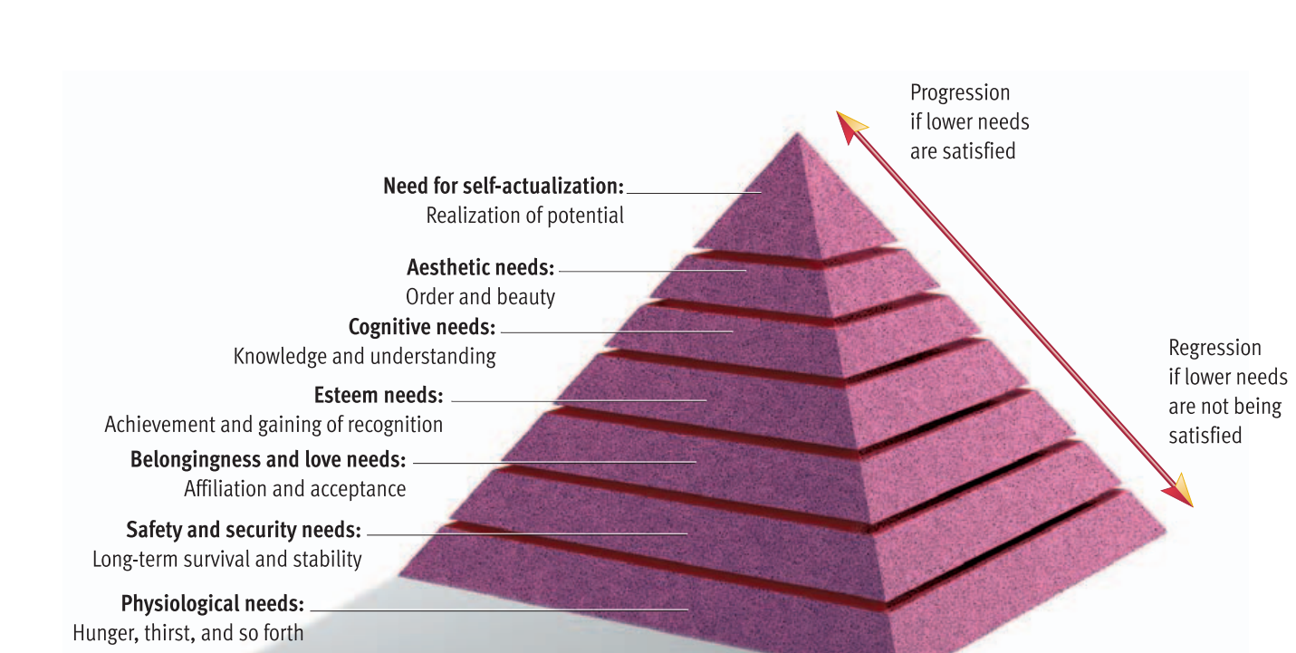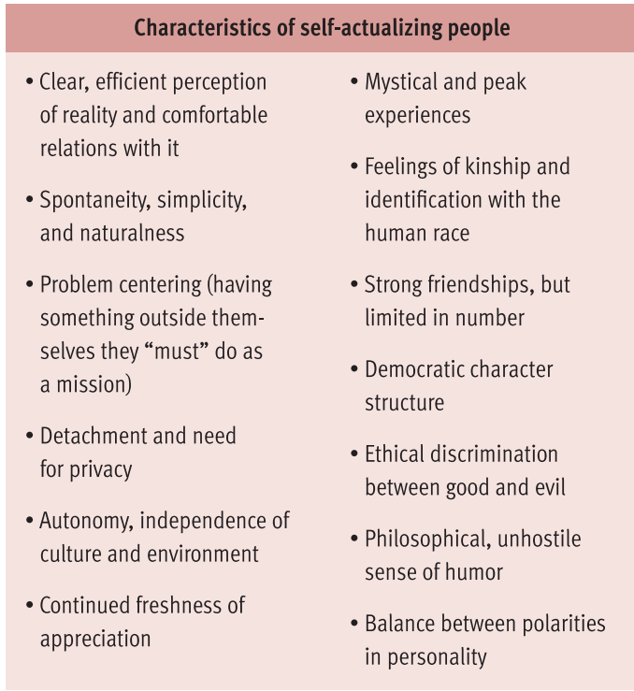

**Hans Eysenck theory**

Jim Lewis and Jim Springer, identical twins separated at birth in 1940, discovered their lives were remarkably similar when reunited in 1979. They shared traits such as driving the same blue Chevrolet, chain-smoking Salems, chewed their fingernails, and owned dogs named Toy and even vacationing at the same beach. Their personalities were also strikingly alike, which highlights findings from a study at the University of Minnesota that explored personality resemblances among identical twins raised apart.

This leads to the question of whether personality is largely inherited. Hans Eysenck, a prominent psychologist, proposed that personality consists of a hierarchy of traits derived from three higher-order traits: extraversion, neuroticism, and psychoticism. Eysenck emphasized that genetics play a significant role in personality development. He theorized that individual differences in physiological functioning influence a person's ability to be conditioned, impacting the personality traits they develop. Specifically, he explored the distinctions between extraversion and introversion, proposing that introverts generally experience higher levels of physiological arousal, which makes them more susceptible to conditioning. Eg, introverts can get hurt more by other’s words directed to that person even if they weren’t and there chances of going to that gathering will reduce.

**Evolutionary theory- David Buss**

Those who could accurately discern traits in others likely had a reproductive advantage.

Building on this, Daniel Nettle posits that these traits themselves evolved because they were beneficial in ancestral environments. For example, extraversion may have increased mating success, neuroticism could have heightened competitiveness and danger avoidance, and agreeableness might have facilitated coalition-building. Nettle also emphasizes the importance of considering the trade-offs of these traits, acknowledging that while they have adaptive benefits, they can also come with potential downsides (e.g., risky behavior associated with high extraversion). Overall, evolutionary perspectives on personality highlight how these traits may have evolved to enhance survival and reproductive success.